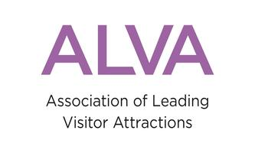
‘New audiences, new stories, new partnerships’
A seminar with presentations and case studies on using performance, theatre, art, VR and AR and storytelling - to draw new audiences and tell your attraction’s stories in new ways.
Thursday 15th March 2018.
The Ballroom, The RAF Club, 128 Piccadilly, London W1J 7PY

Guest speakers:

Programme:

10am Registration and coffee

10.30 Welcome; Bernard Donoghue, Director, ALVA; Chair, LIFT (London International Festival of Theatre)

10.45 Kate Brindley, Director of Collections & Exhibitions,
Chatsworth House, Derbyshire.
‘House Style; Five Centuries of Fashion’.
11.15 Kate McGrath, Director, Fuel Theatre

Working with attractions, such as Historic Royal Places and their ‘Lost Palace project at The Banqueting House, from the perspective of a theatre company.

11.45 Coffee

12.15 Dan Vo, Volunteer, V&A LGBTQ Tours
Curating and presenting tours for LGBTQ audiences; telling stories of the V&A collection to new audiences.

12.40 Jenny Waldman CBE, Director of 14 - 18 NOW.
Presentation on the art, productions, performances and artistic programme which 14 - 18 NOW have commissioned to connect people to the First World War.

1pm Lunch and networking

2pm Welcome back and summary; Bernard Donoghue, ALVA

2.10pm Factory 42; John Cassy, Co-Founder and Chief Executive.
Using VR and AR to bring your stories and collection to life, anywhere.

2.40pm Pippa Shirley, Head of Collections & Gardens and
Simon Wales, General Manager, Waddesdon Manor

Curating an artistic programme in a National Trust property

3.10pm Coffee

3.30pm Rob Kirk, Grande Exhibitions
‘Van Gogh Alive, the experience’. Bringing an interactive, immersive multimedia experience to an attraction near you.

3.50pm Conclusions and any questions

4pm End and depart

